REGRESSION MODEL (ANN)

Basmala Yasser 205045

Samaa Sophy 215009

Menaa Saeed 205088

Aalaa Mokthar 215100

# What IS Regression Model ?

* Machine Learning Regression is a technique for investigating the relationship between independent variables or features and a dependent variable or outcome. It's used as a method for predictive modelling in machine learning, in which an algorithm is used to predict continuous outcomes

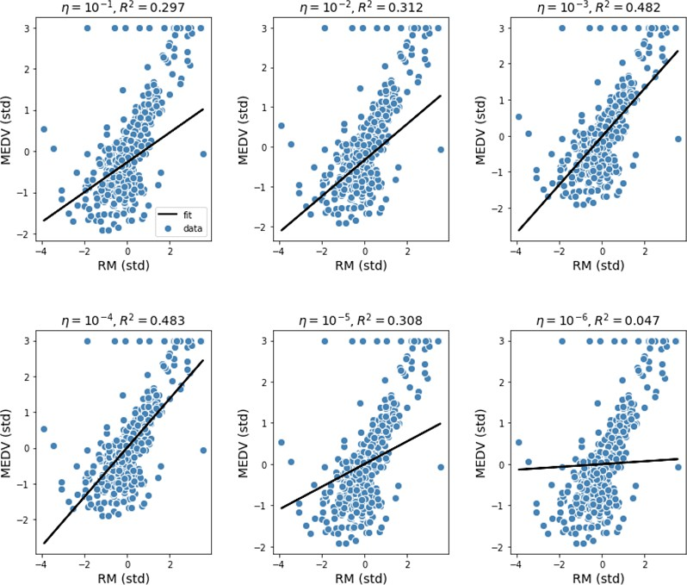

# Regression VS Classification

* The most signif ica nt difference bet ween regression vs classif ication is that while regression helps predict a continuous quantity, classification predicts discrete class labels.

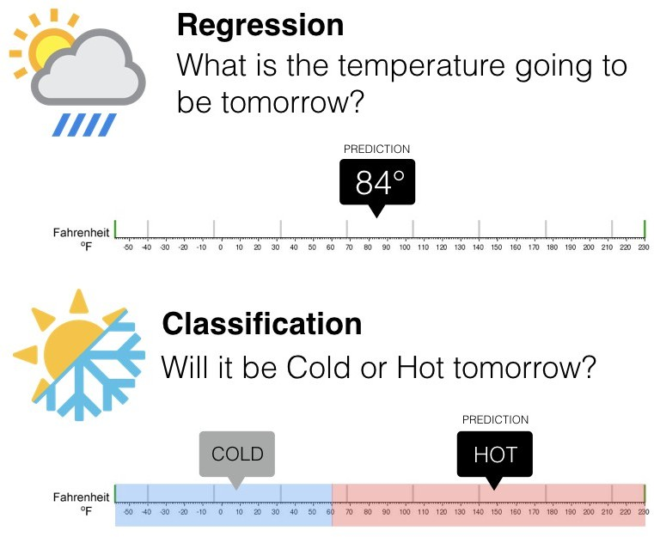

# Project Idea

* how to build models to predict the fuel efficiency of the late-1970s and early 1980s automobiles. To do this, you will provide the models with a description of many automobiles from that time period. This description includes attributes like cylinders, displacement, horsepower, and weight.

# Steps We Follow In Our Project

1. Get the data
2. Clean Dataset
3. Spilt Features from labels
4. Normalization
5. Linear Regression with single input
6. Linear regression with multiple inputs
7. Deploy ANN using flask

# Reference

* + https:

//[www.tensorflow.org/tutorials/keras/regression](http://www.tensorflow.org/tutorials/keras/regression)